WEEK 5
Week Ending: 03-10-2025 |  | DAY: |  | Subject: COMPUTING
Duration: 50mins |  |  |  | Strand: Productivity Software
Class: B7 |  | Class Size: |  | Sub Strand: Introduction to Word Processing
Content Standard:  B7.2.1.1 Demonstrate how to use Microsoft Word (Editing) |  |  | Indicator:  B7.2.1.1.1 Explain the importance of word processing software |  |  |  | Lesson:  1 of 1
Performance Indicator:  Learners can explain the importance of word processing software and describe the uses of different word processing software |  |  |  |  | Core Competencies:  Communication and Collaboration, Critical Thinking and Problem solving
References: Computing Curriculum Pg.
Keywords: Word Processor, Word Processing, Software, Document, Formatting
Phase/Duration | Learners Activities |  |  |  |  | Resources
PHASE 1: STARTER | Brainstorm learners if they have ever typed a document on a computer and what software they used. Discuss their responses briefly.  Show a blank document on the screen using a word processing software like Microsoft Word.  Ask learners what they think this software is used for.
PHASE 2: NEW LEARNING | Introduce the term "word processor" and explain that it refers to software used to create, edit, and format text documents.  Discuss the difference between writing by hand and using a word processor.  Explain why word processing software is important, such as making it easier to edit documents, use templates, check spelling and grammar, and format text for various purposes.  Define a word processor as a software application that allows users to create, edit, and format text documents.  Have learners mention some examples of word processors and their uses.  - Microsoft Word: Widely used for creating and editing documents.  - Google Docs: Cloud-based word processor that allows for collaboration.  - LibreOffice Writer: Free, open-source word processing software.  - Apple Pages: Word processor available on Apple devices, known for its design features.  Learners in their groups talk about the importance of word processors.  - Editing: Easy to make changes without rewriting the entire document.  - Formatting: Ability to change font size, style, and color, add images, and organize text with bullet points or numbered lists.  - Templates: Use of pre-designed layouts for different types of documents like letters, resumes, and reports.  - Spelling & Grammar Check: Helps in identifying and correcting mistakes in the text.  Use a computer to demonstrate basic features of a word processor, such as typing text, formatting (bold, italics, underline), and saving a document.  Provide learners with access to computers.  Ask them to open a word processing software (e.g., Microsoft Word or Google Docs), type a short paragraph about their favorite hobby, and format the text by changing the font, size, and color.  They should also save the document with an appropriate file name.  For learners who need extra help, provide a step-by-step guide on using basic features of a word processor. Offer one-on-one assistance if necessary.  Assessment  - What is a word processor?  - Name two examples of word processing software.  - Why is word processing software important? |  |  |  |  | Computers with word processing software installed  Screenshots of different word processors
PHASE 3: REFLECTION | - What are some common uses of Microsoft Word?  - How does Google Docs differ from Microsoft Word?  Use peer discussion and effective questioning to find out from learners what they have learnt during the lesson.  Take feedback from learners and summarize the lesson.

Week Ending: 03-10-2025 |  | DAY: |  | Subject: COMPUTING
Duration: 50mins |  |  |  | Strand: Productivity Software
Class: B7 |  | Class Size: |  | Sub Strand: Introduction to Word Processing
Content Standard:  B7.2.1.1 Demonstrate how to use Microsoft Word (Editing) |  |  | Indicator:  B7.2.1.1.2 Explore the features of MS-word interface or window |  |  |  | Lesson:  1 of 1
Performance Indicator:  Learners can  - Identify and describe the key features of the Microsoft Word interface.  - Navigate through the different tabs and ribbons in MS Word. |  |  |  |  | Core Competencies:  Communication and Collaboration, Critical Thinking and Problem solving
References: Computing Curriculum Pg.
Keywords: Ribbon, Quick Access Toolbar, Status Bar, Tabs, Document Window
Phase/Duration | Learners Activities |  |  |  |  | Resources
PHASE 1: STARTER | Ask learners if they have ever used Microsoft Word and what they use it for. Discuss their responses briefly.  Display a blank MS Word document on the screen and ask learners to identify any familiar buttons or tools they see. Allow them to point out and guess the function of different parts of the interface.
PHASE 2: NEW LEARNING | Introduce the concept of the MS Word interface as the screen layout where all the tools and commands are located.  Explain that understanding the interface is crucial for efficiently using the software.  Discuss why it’s important to know the different parts of the MS Word interface, such as being able to format documents quickly, find tools, and use shortcuts.  Guide learners to discuss the features of the MS-word interface  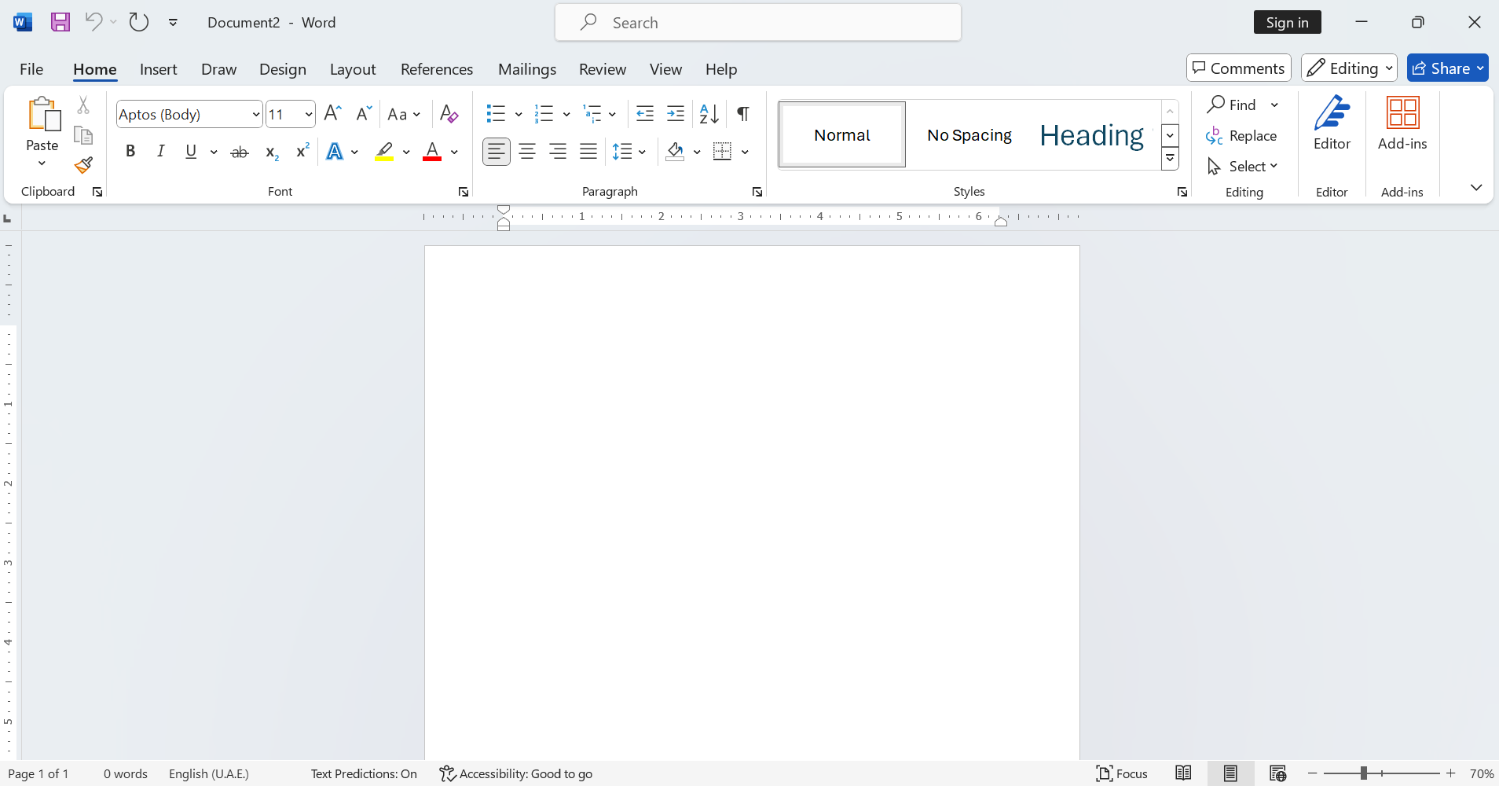  - Ribbon: Explain that the ribbon is the top section with tabs like Home, Insert, Design, etc., each containing groups of commands for different tasks.  - Quick Access Toolbar: Located above the ribbon, this toolbar allows quick access to commonly used commands such as Save, Undo, and Redo.  - Tabs and Groups: Each tab on the ribbon organizes commands into groups (e.g., Font, Paragraph) for easy access.  - Document Window: This is the main area where you type and edit your document.  - Status Bar: Found at the bottom of the window, it displays information about the document, such as page number, word count, and zoom level.  Use a computer to navigate through the MS Word interface, showing how to switch between tabs, use the Quick Access Toolbar, and observe the status bar.  Demonstrate simple tasks like bolding text, inserting an image, and saving a document.  Provide learners with access to computers. Ask them to open Microsoft Word and identify the different parts of the interface discussed.  They should practice switching between tabs, using the ribbon to format text, and exploring the Quick Access Toolbar and status bar.  For learners who need extra help, provide a simplified guide with screenshots highlighting the key features of the MS Word interface. Offer one-on-one assistance if necessary.  Assessment  - What is the ribbon in Microsoft Word?  - Where can you find the Quick Access Toolbar, and what is its purpose?  - Name two tabs you can find in the ribbon and describe their functions. |  |  |  |  | Computers with Microsoft Word installed  Screenshots or printouts of the MS Word interface
PHASE 3: REFLECTION | - What information does the status bar display?  - Where do you type and edit text in MS Word?  Use peer discussion and effective questioning to find out from learners what they have learnt during the lesson.  Take feedback from learners and summarize the lesson.

Week Ending: 03-10-2025 |  | DAY: |  | Subject: COMPUTING
Duration: 50mins |  |  |  | Strand: Productivity Software
Class: B7 |  | Class Size: |  | Sub Strand: Introduction to Word Processing
Content Standard:  B7.2.1.1 Demonstrate how to use Microsoft Word (Editing) |  |  | Indicator:  B7.2.1.1.2 Demonstrate how to insert, select, delete and move text |  |  |  | Lesson:  1 of 1
Performance Indicator:  Learners can  - Insert, select, delete, and move text within a document in Microsoft Word.  - Apply editing tools to perform basic text manipulation. |  |  |  |  | Core Competencies:  Communication and Collaboration, Critical Thinking and Problem solving
References: Computing Curriculum Pg.
Keywords: Insert, Select, Delete, Move, Overtype
Phase/Duration | Learners Activities |  |  |  |  | Resources
PHASE 1: STARTER | Ask learners if they have ever made a mistake while typing and how they fixed it.  Discuss different methods they used, such as deleting or retyping.  Display a short sentence on the screen with an error and demonstrate how to correct it by inserting, selecting, deleting, and moving text.
PHASE 2: NEW LEARNING | Introduce the concept of editing tools in Microsoft Word. Explain that these tools allow users to make changes to their text quickly and efficiently without having to rewrite everything.  Discuss why knowing how to use these tools is essential for creating professional-looking documents, such as fixing errors, rearranging content, and improving the overall clarity of the text.  Explain that inserting text allows users to add new words or phrases into an existing sentence or paragraph.  Demonstrate how to select text using the mouse or keyboard shortcuts (e.g., clicking and dragging or using Shift + arrow keys).  Show how to delete text using the Backspace or Delete keys, and explain the difference between the two.  Demonstrate how to cut and paste text to move it from one location to another within a document.  Take learners through a demonstration to distinguish between the Overtype and insert Mode.  - Insert Mode: Explain that this is the default mode in which new text pushes existing text forward.  - Overtype Mode: Show how to enable this mode via the status bar, which replaces existing text as you type.  Use a computer to demonstrate these editing tools. For the overtype/insert option, right-click the status bar and enable the overtype option, then demonstrate how typing in this mode affects the existing text.  Provide learners with access to computers. Ask them to open a Microsoft Word document and practice:  - Inserting new text into a sentence.  - Selecting and deleting a specific word or phrase.  - Moving a sentence from one part of the document to another.  - Switching between insert and overtype modes and observing the difference.  For learners who need extra help, provide a simplified guide with step-by-step instructions on using the editing tools and activating the overtype mode. Offer one-on-one assistance if necessary.  Assessment  - What is the difference between the insert and overtype modes in Microsoft Word?  - How do you select text in a document?  - What is the quickest way to delete a word using the keyboard? |  |  |  |  | Computers with Microsoft Word installed  Screenshots or printouts demonstrating the overtype/insert option
PHASE 3: REFLECTION | - Explain how to move a paragraph to a different location in a document.  - How do you enable the overtype mode in Microsoft Word?  Use peer discussion and effective questioning to find out from learners what they have learnt during the lesson.  Take feedback from learners and summarize the lesson.

